|  |  |  |  |
| --- | --- | --- | --- |
| 1 | | 820,176 | |
| **NUMERO DE FRONTERAS** | | **ENERGIA AGREGADA** | |
|  | | | |
| 123,996,003 | 26 | | 4,992,000 |
| INGRESO 2020 | DÍAS CERTIFICADOS 2020 | | ENERGIA RESPALDADA 2020 |
|  | | | |
| 2,102,806,652 | 191 | | 91,421,385 |
| INGRESO 2021 | DÍAS CERTIFICADOS 2021 | | ENERGIA RESPALDADA 2021 |

**HISTORICO REINTEGRO DDV**

|  |  |  |
| --- | --- | --- |
|  | **2020** | **2021** |
| **ENE** | - | 92.02 |
| **FEB** | - | 119.82 |
| **MAR** | - | 70.81 |
| **ABR** | - | 41.28 |
| **MAY** | - | 398.13 |
| **JUN** | - | 340.43 |
| **JUL** | - | 440.66 |
| **AGO** | - | 97.18 |
| **SEP** | - | 313.58 |
| **OCT** | - | 188.9 |
| **NOV** | - | - |
| **DIC** | 124.0 | - |

**Los valores de la tabla están en millones de COP**

**REINTEGRO MECANISMO DDV OCTUBRE 2021**

|  |  |  |  |  |  |
| --- | --- | --- | --- | --- | --- |
| FECHA | TIPO DIA | CANTIDADES RESPALDO | PRECIO PONDERADO USD | TRM | PNETO |
| 2021-10-06 | Miércoles | 500,935 | 5.98 | 3,784.44 | 10,384,358 |
| 2021-10-07 | Jueves | 500,703 | 5.98 | 3,784.44 | 10,379,549 |
| 2021-10-08 | Viernes | 497,415 | 5.98 | 3,784.44 | 10,311,389 |
| 2021-10-09 | Sábado | 503,815 | 5.98 | 3,784.44 | 10,444,060 |
| 2021-10-10 | Domingo - Festivo | 542,652 | 5.98 | 3,784.44 | 11,249,150 |
| 2021-10-11 | Lunes | 503,671 | 5.98 | 3,784.44 | 10,441,075 |
| 2021-10-12 | Martes | 500,935 | 5.98 | 3,784.44 | 10,384,358 |
| 2021-10-13 | Miércoles | 500,719 | 5.98 | 3,784.44 | 10,379,880 |
| 2021-10-14 | Jueves | 497,432 | 5.98 | 3,784.44 | 10,311,741 |
| 2021-10-19 | Martes | 503,815 | 5.98 | 3,784.44 | 10,444,060 |
| 2021-10-20 | Miércoles | 505,500 | 5.98 | 3,784.44 | 10,478,990 |
| 2021-10-21 | Jueves | 497,432 | 5.98 | 3,784.44 | 10,311,741 |
| 2021-10-22 | Viernes | 503,815 | 5.98 | 3,784.44 | 10,444,060 |
| 2021-10-23 | Sábado | 542,652 | 5.98 | 3,784.44 | 11,249,150 |
| 2021-10-24 | Domingo - Festivo | 503,655 | 5.98 | 3,784.44 | 10,440,744 |
| 2021-10-25 | Lunes | 500,919 | 5.98 | 3,784.44 | 10,384,026 |
| 2021-10-26 | Martes | 500,703 | 5.98 | 3,784.44 | 10,379,549 |
| 2021-10-27 | Miércoles | 505,503 | 5.98 | 3,784.44 | 10,479,053 |

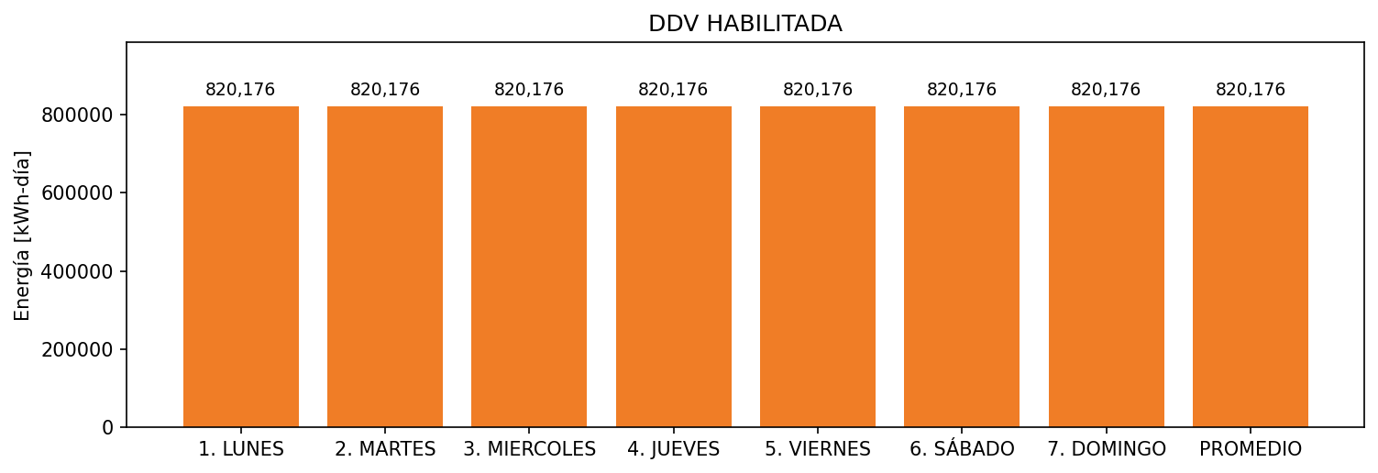

|  |  |  |  |  |  |  |  |  |  |
| --- | --- | --- | --- | --- | --- | --- | --- | --- | --- |
| **FRONTERA** | **COD SIC** | **FRT DDV** | **TIPO DDV** | **PROMEDIO** | **PRÓXIMA ACTUALIZACIÓN** | **MARGEN DE ERROR** | **ÚLTIMA PRUEBA DDV** | **DÍAS PARTICIPACIÓN** | **FECHA REFERENCIA PRÓXIMA PRUEBA DDV** |
| Quifa III - Quifa IV | Frt24197 | Frt37374 | LBC | 820,176 | 2022-03-04 | 4,31 | 2021-08-11 | 47.0 | 2022-01-10 |